Virtual Reality Environment for Brain-Computer Interface
Usage & Development Documentation
May 4th, 2026

Client: Dr. Alan Chiu
Advisor: Dr. Sriram Mohan
Brian Beasley, Garrett Doolittle, Jared Kagay, & Jacob Van Dyke

Contents
Contents 2
1 | Technological Dependencies 3
1.1 | Hardware Requirements 3
1.2 | Hardware Setup 3
1.3 | Software Requirements 3
1.4 | Software Setup 4
1.5 | Ongoing Set-Up 4
2 | Intended Workflow 4
2.1 | Preparation Phase 5
2.2 | Execution Phase 5
2.3 | Reflection Phase 5
3 | Customize Session 5
3.1 | Target Settings 6
3.2 | The Parameter Groups 6
3.3 | Export Configuration 10
4 | Start New Session 11
4.1 | Trial Data 11
5 | Review Past Sessions 13
5.1 | Interactive View 13
5.2 | Statistical View 13

Technological Dependencies
The following is step-by-step guide to running trials using the software, starting from the initial set-up of the trial environment and the ongoing usage checklist.

Hardware Requirements
To use the virtual reality system there are many required pieces of hardware. All these pieces should be contained within the two boxes, but if not the pieces needed for the system to work correctly are the following:
- Varjo Aero Headset with Galea EEG apparatus or similar Varjo headset
- At least two valve base stations (Vive SteamVR Base Station 2.0 Lighthouse)
- Two VR controllers (HTC Vive SteamVR Controller 1 or equivalent)
- An adequate PC or laptop: see the Varjo Aero minimum requirements
- Laptop Adapter with power cable
- Varjo 5m USB-C Cable

Hardware Setup
The first-time setup for the hardware listed above is as follows:
            - Find a clear area at least 6.5 ft x 6.5 ft with walls on at least two sides
            - Place the two base stations diagonally from each other in two of the corners at least 6.5 ft off the ground and plug them in.
            - If you have more base stations place them in the other two corners and plug them in.
            - Connect the headset to the PC with a display port and USB-A cable or Laptop with the laptop adapter and 5m USB-C cable.

Software Requirements
            - Steam
            - SteamVR
            - Varjo Base
            - Virtual Reality Environments Application
These are the customer service pages for the above applications: Steam, SteamVR, and Varjo Base.

Software Setup
After setting up the hardware and installing the necessary software for the first time, there are a few setup steps that only have to happen once each time you change the play area.
            - Turn on the controllers by holding the lower button above the LED.
            - Open Varjo Base
            - Open SteamVR
            - Varjo Base should prompt a play-area calibration. Follow the steps outlined in the calibration process
            - SteamVR may say that the Base Stations are on the same channel. To Fix this there is a button in the small hole on the back of the base stations to change the channel.
Once these steps are completed the system should be ready to use.

Ongoing Set-Up
Assuming the headset is unplugged and the laptop is powered down, these steps must be completed to give each participant a smooth experience. They do not need to be redone in between trials, but it is recommended to unplug the headset and power down laptop in between sets of trials for long-term system preservation. It is important the software are opened in this order to properly boot up the headset.
            - Connect the headset to the PC with a display port and USB-A cable or Laptop with the laptop adapter and 5m USB-C cable and plug the headset in.
            - Turn on the controllers by holding the lower button above the LED.
            - Open Varjo Base
            - Open SteamVR
            - Open the Virtual Reality Environments Application
            - Once the headset is on, calibrate the headset. If the button on the side of the headset is not working. Open the Varjo Base application and click calibrate in the app.
While the previously mentioned customer service pages would be helpful here as well, consider also contacting EIT about technological issues.

Intended Workflow
The following sections outline the intended steps for initializing, conducting, and analyzing trials. Conducting a sequence of events other than what is described below might lead to unintended errors. Throughout this process, the application does most of the work to save files and folders automatically, described as follows:
- Trial Settings File: Automatically named with the configuration name in a JSON file. Will be saved automatically in the TrialFiles folder. You should just be able to click Save File when the file explorer opens unless you want to specify a custom name, save location, or subfolder.
- Session Information: All session information including the trial settings, target locations, and all gathered data during a trial will be saved to a directory named with the session name, participant id, and time of creation. At the end of a trial, you can select where this folder is saved. The application selects a default TrialRuns folder. You can simply just click Select Folder unless you want to specify a custom save location or subfolder, but you do not need to create an additional folder, as the application will do that for you.
- Export Data: While analyzing a statistical view of a particular trial, you can click Export to save a copy of the processed data. This will give three CSV files for the data related to the left-hand deviations, the right-hand deviations, and the overall statistics. The application selects the folder where the trial run is stored by default, so if that is the intended location, simply press Select Folder. Otherwise, navigate to a particular folder (e.g. Downloads) and click to select that folder instead.

Preparation Phase
At this point in the trial, the user has a solid understanding of the kind of trial you want to run for multiple participants. Once logged into the software, navigate to the Customize Session page. Navigating through each of the sub-menus, the user can change each of the settings or leave them as their default values, but the configuration name and target locations are required fields. Once the configuration is finalized, selecting the Save Customization button will save a JSON file to the computer’s local files. The idea is that one configuration file for one trial is used across several sessions for several different participants.

Execution Phase
By the execution phase, the user and a participant are present in the trial room, ready to complete a session. Once the pre-trial communications are completed, it is recommended to first run the program, put the headset on the participant, and then start the trial on the computer. Regardless of the order, the user should click on Start New Session, enter the Session Name and Participant ID, upload the previously-created configuration file, add any notes, and finally press the Begin Session button. The user should not continue until the headset has been put on the participant. Once everything is ready, they select Start Trial, wait for the participant to complete it, select End Trial, and finally Go Home. Once all those steps have been completed, the raw trial data is saved to the computer for further review. The user can add additional notes at any point between beginning the session and going home.

Reflection Phase
Once a trial has been completed, the user can move on to the reflection phase. First, navigate to Review Past Sessions and upload the folder containing the raw data. The session information should populate on the screen if the data is valid. The user is free to examine the interactive view of the movement paths and the statistical overview without having to re-upload the data. Additionally, the data analysis can be exported for further examination, if desired, but be aware that viewing the file is slightly less intuitive than the in-program parsed version.

Customize Session
The Customize Session page consists of various parameters related to the specifics of the core reaching trial. Once the name is set, the target locations are uploaded, and the additional parameters are updated, the configuration can be exported for future use across different participants in a particular trial.

Target Settings
Declaring the locations of targets during a trial requires either a CSV or JSON file. The values are in meters in x, y, and z coordinate directions. The trial is not affected in any way by the method of uploading the target locations. An example of a target CSV is as follows:
targets.csv
x | y | z
0.1 | 0.5 | 0.7 | The first target will be at <x,y,z>=<0.1,0.5,0.7> m,
-0.5 | 0.2 | 0.5 | the second target will be at <x,y,z>=<-0.5,0.2,0.5> m,
0.4 | -0.9 | 0.3 | and the third target will be at <x,y,z>=<0.4,-0.9,0.3> m.

Similarly, the JSON file should be created as follows:
targets.json
{  "targets": [  {"x": 0.1, "y": 0.5, "z": 0.7},  {"x": -0.5, "y": 0.2, "z": 0.5},  {"x": 0.4, "y": -0.9, "z": 0.3}  ]  } | The first target will be at <x,y,z>=<0.1,0.5,0.7> m,  the second target will be at <x,y,z>=<-0.5,0.2,0.5> m,  and the third target will be at <x,y,z>=<0.4,-0.9,0.3> m.
For reachability purposes, assuming the participant is standing still and does not lean or step in the direction of the target, the target should be between -0.9 and +0.9 in the x-direction, -1.0 and +0.6 in the y-direction, and +0.1 and +0.8 in the z-direction. These values are for a 6 foot participant reaching as far as possible in each direction without leaning or moving, but the user should probably double-check the feasibility of the trial before it is run with a real participant.

The Parameter Groups
The following tables attempt to explain the complexities of each trial customization parameter. The one parameter not mentioned below, Configuration Name, is simply a string value to help you identify each configuration when a trial is being run. The buttons on the left side of the page are used to show and hide the various menus containing the described parameters. The only reason they are separated into groups is because they don’t all fit on the page at the same time, so don’t focus too much on the groupings themselves.

Visibility Settings
Parameter | Input | Description
Hand Visibility | Full, Flicker, None (dropdown)  Default: Full | When set to Full, the hands will be shown throughout the entire duration of the trial. When set to Flicker, the hands will flicker on and off when not in contact with a target (see Hand Flicker Show/Hide and Show Hands in Proximity). When set to None, the hands will be permanently hidden after the initial target is reached.
Target Visibility | Full, Flicker, None (dropdown)  Default: Full | When set to Full, the targets will be shown throughout the entire duration of trial. When set to Flicker, the targets will flicker on and off after the previous target has been reached and before they have been reached (see Target Flicker Show/Hide). When set to None, the targets will only be shown after they have been reached.
Hand Flicker Show | positive decimal (in seconds)  Default: 1 sec | Assuming Hand Visibility is set to Flicker, the participant’s hands will show for Hand Flicker Show seconds, then hide for Hand Flicker Hide seconds.
Hand Flicker Hide | positive decimal (in seconds)  Default: 1 sec
Target Flicker Show | positive decimal (in seconds)  Default: 1 sec | Assuming Target Visibility is set to Flicker, the participant’s hands will be shown for {Target Flicker Show} seconds, then hidden for {Target Flicker Hide} seconds.
Target Flicker Hide | positive decimal (in seconds)  Default: 1 sec
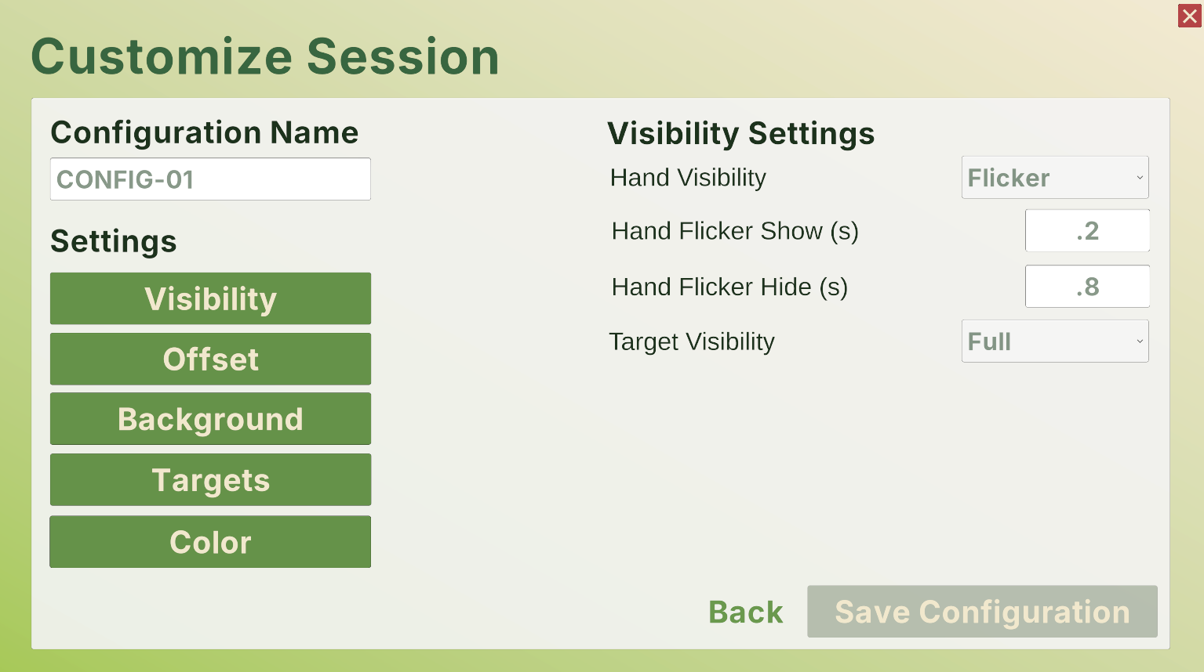

Offset Settings
Parameter | Input | Description
Type | None, Fixed, Randomized (dropdown)  Default: None | All in-trial object interactions rely on the actual position of the participant’s hand controllers, but these settings allow for the visual representation of their hands to be offset by a customizable amount. If set to None, the hand displayed will be accurate to the hand controller locations. If set to Fixed, a set offset will be applied to the hand displayed. If set to Randomized, a variable offset will be applied differently to each participant. The randomization process uses the given standard deviation (see X, Y, and Z) along with a normal distribution to calculate the offset value.
X | decimal (centimeters)  Default: 0 cm | If this value is positive, the displayed hand will be offset to the right, and vice versa.
Y | decimal (centimeters)  Default: 0 cm | If this value is positive, the displayed hand will be offset upwards, and vice versa.
Z | decimal (centimeters)  Default: 0 cm | If this value is positive, the displayed hand will be offset forward, and vice versa.
Target Proximity Radius | non-negative decimal (centimeters)  Default: 10 cm | The analyzed data is separated into categories for Seek, Approach, and Search. The Approach portion is when the participant is in some proximity to the target, but they have not reached the target yet. This value adds the given number to the radius of the target itself to create a new invisible sphere that surrounds the target for collision purposes.
Show Hands in Proximity | true, false  (toggle)  Default: Unselected | If this checkbox is checked, when the participant is within proximity of the target (see Target Proximity Radius), their hands will be permanently shown (see Hand Visibility). This has no effect when the hands are already always shown.
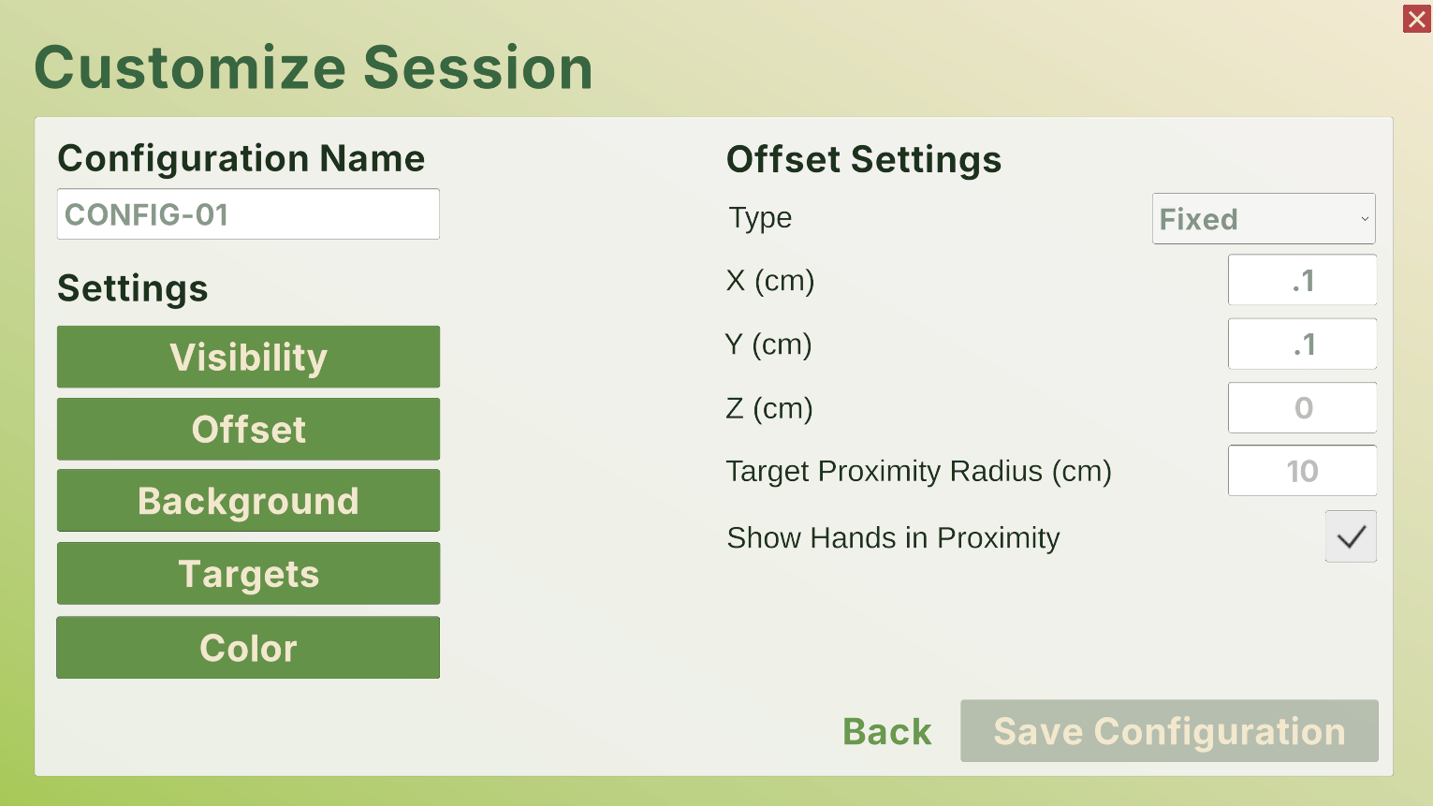

Background Settings
Parameter | Input | Description
Background | image.png, image.jpg, image.jpeg, video.mov, video.mp4  (file upload) | By default, the background will be set to Unity’s standard blue sky and gray floor. However, the user can upload an image or video to constantly play in the background of the trial if desired. Keep in mind that 360-degree media will show the best results for immersion, which can be found on standard stock media websites for free or paid.
Moving Objects | true, false  (toggle)  Default: Unselected | In tandem with the default, image, or video background options, if this box is checked, the program will generate various three-dimensional objects moving throughout the participant’s frame of view (see Object Direction/Speed/Quantity/ Color/Size).
Object Direction | Right, Left,  Up, Down, Forward, Backward, (dropdown)  Default: Right | Assuming Moving Objects is checked, this sets the direction of the motion of the object. For example, if set to Right, the objects will spawn to the left of the participant, then move toward the right of the participant.
Object Speed | positive decimal (meters per second)  Default: 10 m/s | Assuming Moving Objects is checked, this sets how fast the objects move throughout the three-dimensional space.
Object Quantity | positive integer (objects per minute)  Default: 100 | Assuming Moving Objects is checked, this sets the number of objects that are spawned each minute of the trial.
Object Color | XXXXXX (hexadecimal color code)  Default: 000000 (black) | Assuming Moving Objects is checked, this sets the color of the objects using a hexadecimal color code (e.g. 8ED873 for ).
Object Size | positive decimals  (centimeters)  Default: 25, 25, 100 | Assuming Moving Objects is checked, this sets the length, height, and width of the generated cubes.
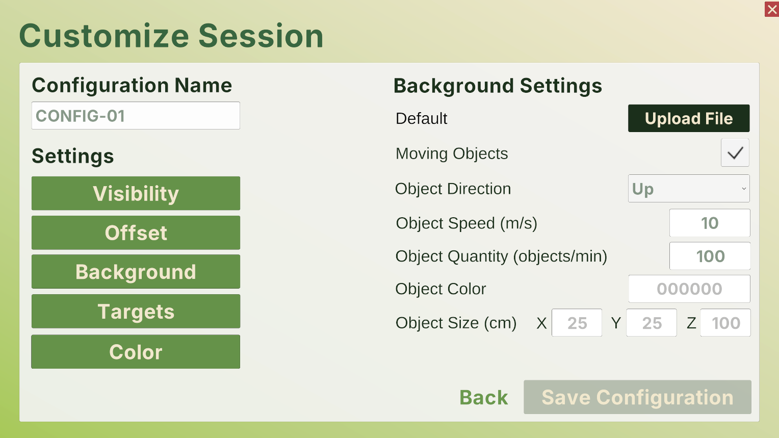

Target Settings
Parameter | Input | Description
Targets | targets.csv  (file upload) | As one of the most important parameters, this allows the user to upload the specific coordinates of each target for the participant to reach for. See the Target Settings section for more information about the target file format.
Time Before Start | non-negative decimal  (seconds)  Default: 3 sec | When the user selects to begin the trial, the participant will be given an initial target to reach for. To start the trial, they will have to hold their hand on that target for this number of seconds before the next target appears. After that, the next target will appear instantly upon collision.
Target Radius | non-negative decimal (centimeters)  Default: 5 cm | This sets the radius of all the targets during the trial, which affects the three-dimensional space that the participant is reaching toward.
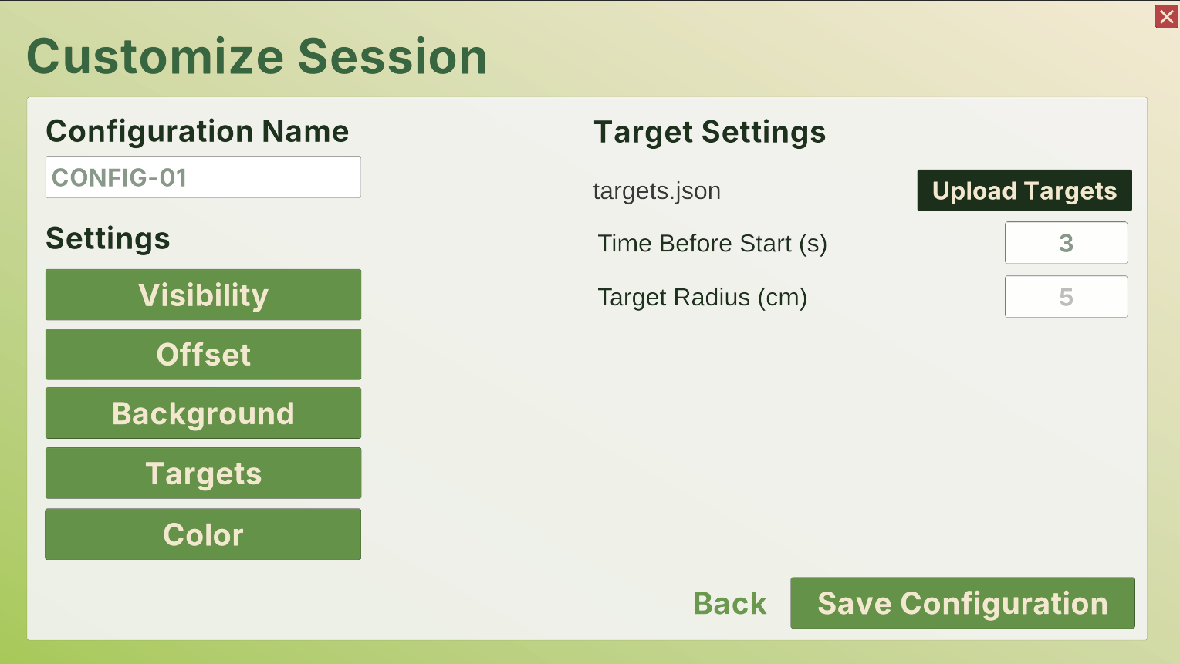

Color Settings
Parameter | Input | Description
Left Hand Color | XXXXXX (hexadecimal color code)  Default: 0000FF (blue) | This sets the color of the participant’s left hand using a hexadecimal color code (e.g. 8ED873 for ).
Right Hand Color | XXXXXX (hexadecimal color code)  Default: FF0000 (red) | This sets the color of the participant’s right hand using a hexadecimal color code (e.g. 8ED873 for ).
Target Color | XXXXXX (hexadecimal color code)  Default: C0C0C0 (silver) | This sets the color of the reaching targets using a hexadecimal color code (e.g. 8ED873 for ).
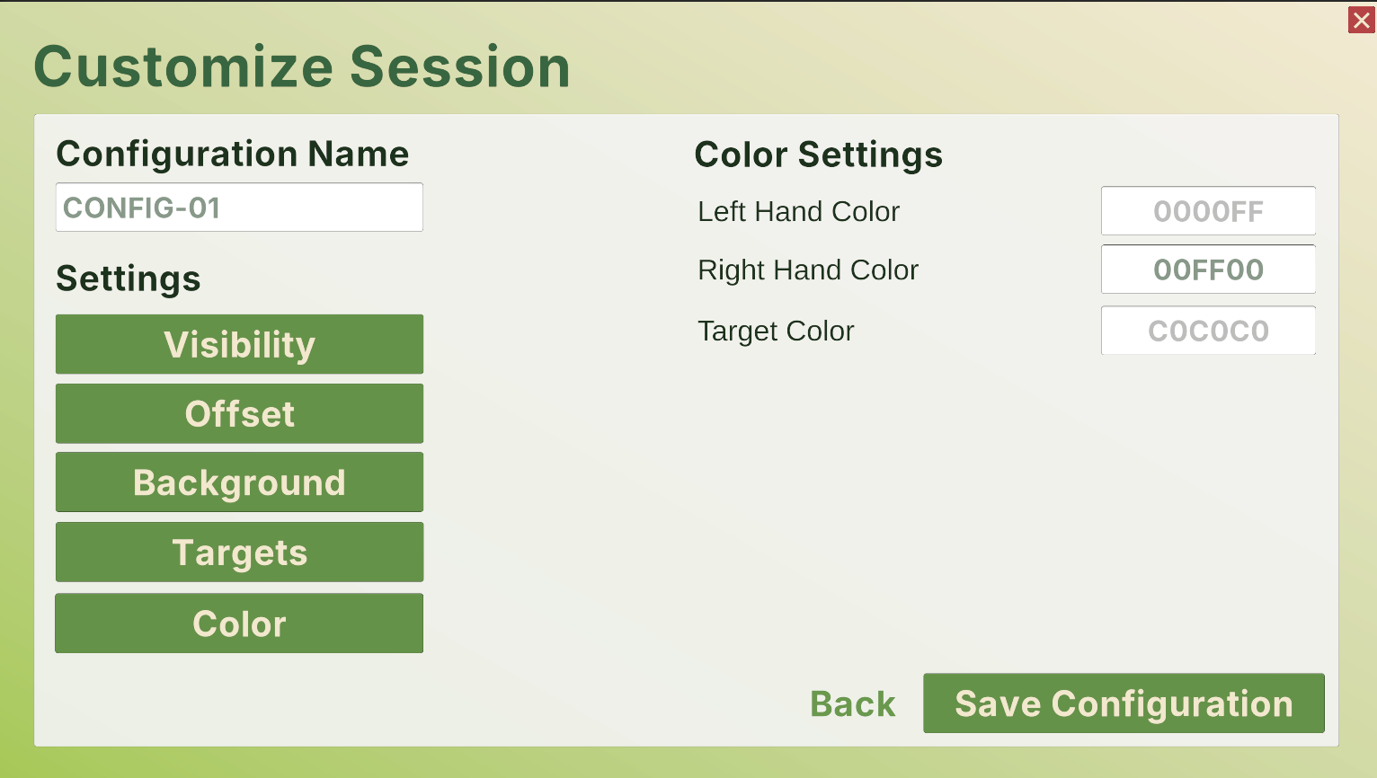

Export Configuration
Once the configuration has a name, target locations, and each of the other parameters have been modified as desired, saving that information can be done by selecting Save Configuration. While the software cannot modify an existing configuration, a new one can be created or the file can be manually modified, preserving the JSON format. Ideally, changes to a configuration are made before the trial is run with real participants to avoid any complications.

Start New Session
The Start New Session and Live Trial View pages are relatively simple from the perspective of the user, as most of the process relies on the participant. First, the user enters a name for the session (this is solely for future identification, so keep it unique and memorable, but it will be saved along with a timestamp) and the participant’s identifier, uploads the configuration settings for the trial (see the Customize Session section), and adds any initial notes about the session. From there, select Begin Session to see the trial from perspective of the participant. Assuming the headset has been put on, select Begin Trial and wait for the participant to complete each reaching task. At any point, the user can log notes that are timestamped when they start typing for future reference. Once the participant has completed the trial, select End Trial. After any last notes are taken, press the Go Home button to return to the home page, save the raw trial data, and complete the session for this participant.
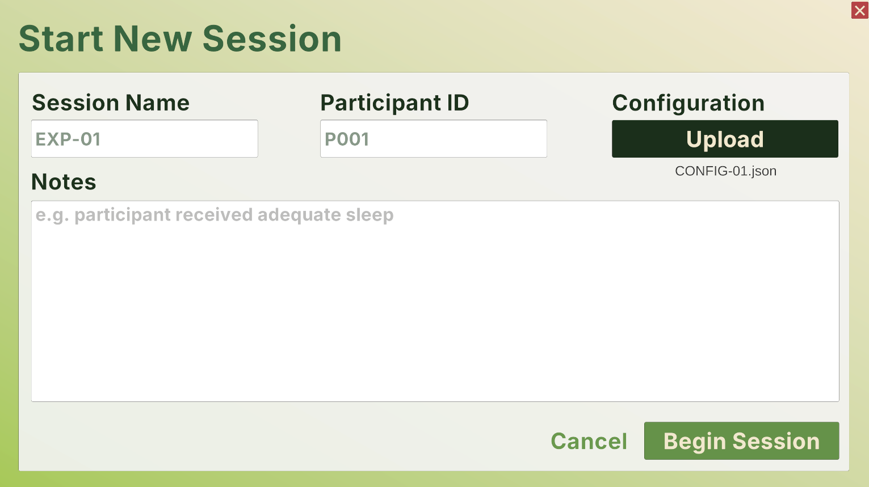

Trial Data
This file will have a lot of information, but each row is simply a moment in time of the trial from the perspective of each of the following variables:
Column | Description
Timestamp | The timestamp of the data point, starting when the user presses Start Trial and ending when they press End Trial. Ideally, Unity tries to capture this information every 25 milliseconds.
Lx  (left hand  x-position) | These three points represent the location of the user’s left hand in three-dimensional space. Each measurement is given in meters where +X is to their right, +Y is upward, and +Z is forward.
Ly
(left hand
y-position)
Lz
(left hand
z-position)
LqX  (left hand  x-rotation) | These four points represent the orientation of the user’s left hand in three-dimensional space.
LqY
(left hand
y-rotation)
LqZ
(left hand
z-rotation)
LqW
(left hand rotation scalar)
Rx  (right hand  x-position) | These three points represent the location of the user’s right hand in three-dimensional space. Each measurement is given in meters where +X is to their right, +Y is upward, and +Z is forward.
Ry
(right hand
y-position)
Rz
(right hand
z-position)
RqX  (right hand  x-rotation) | These four points represent the orientation of the user’s right hand in three-dimensional space.
RqY
(right hand
y-rotation)
RqZ
(right hand
z-rotation)
RqW
(right hand rotation scalar)
Gx  (gaze origin x-position) | These three points represent the center position between the user’s pupils offset from the center of the nose in meters.
Gy
(gaze origin y-position)
Gz
(gaze origin z-position)
Glx  (gaze look x-direction) | These three points represent the direction the user is looking.
Gly
(gaze look y-direction)
Glz
(gaze look z-direction)
Gf  (gaze forward distance) | This point represents the distance of the gaze of the user in meters.
Lpd  (left pupil diameter) | This point is the diameter of the user’s left pupil in millimeters.
Rpd  (right pupil diameter) | This point is the diameter of the user’s right pupil in millimeters.
If this data should be parsed in a certain way, ask a LLM like ChatGPT, Gemini, or Claude to write a Python script that performs the desired functionality. It might be helpful to upload both an example data file with a few rows of data, along with the above table outlining the meaning of each column.
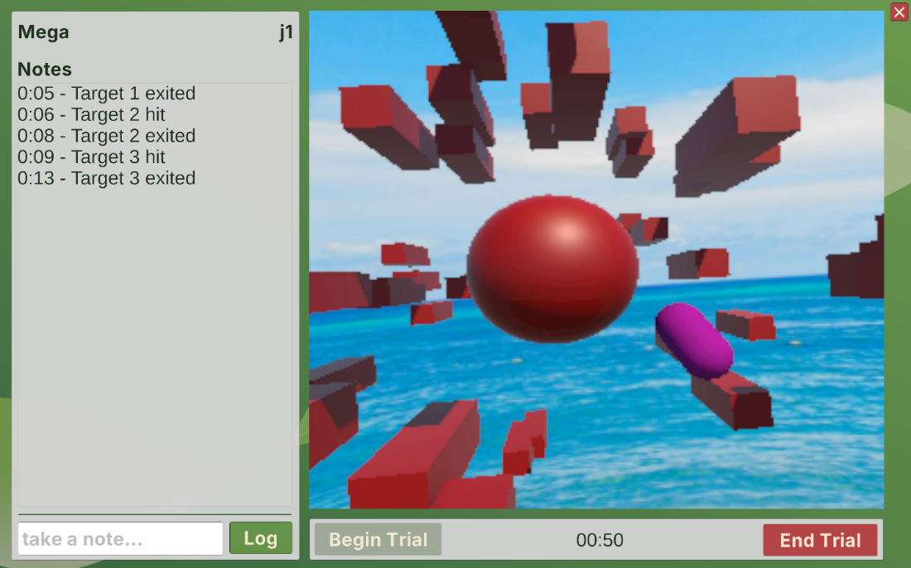

Data Output
When saving the data from a trial, you will save a folder that has three files. One is the configuration JSON which has the session name, participant id, any notes before the trial begin, and the list of settings used in that trial. Another file will be the trial data of position and orientation data collected during the trial stored in a CSV file. The final file is a list of events. This JSON file will store the timestamps of when participants enter a proximity, hit a target, reenter a target, exit a target, or the user inputs a note during the trial. These timestamps correspond to the timestamps of the position and orientation data in the CSV file. The data visualizer uses these files to present the data visually and do some of the preliminary calculations. However, since the data is just saved locally, it can be uploaded or used in other applications.

Review Past Sessions
The Review Past Session page allows the user to do a top-level analysis of the data, focusing on the deviations from the optimal path between targets. First, upload the folder with the session’s results to start reviewing the data, which will enable buttons to switch to the Interactive View page and the Statistical View page. Issues might be encountered if data was collected from an older version of the program than ran on a newer version or vice versa.
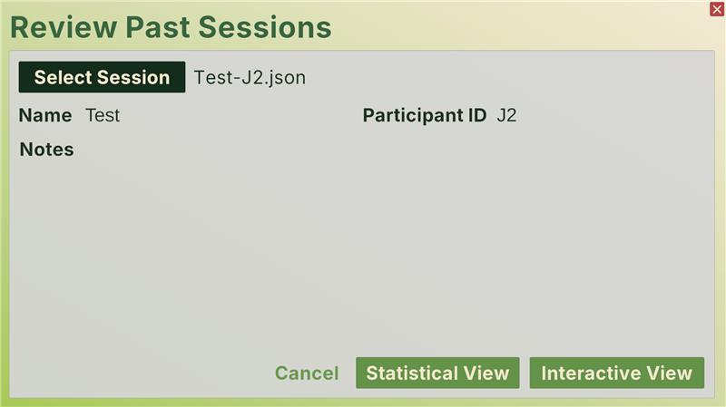

Interactive View
The Interactive View page generates the movement path of the reaching trial in three-dimensional space for the user to inspect visually. Moving around the space is done by pressing Ctrl for down, Shift for up, Up Arrow for forward, Down Arrow for backward, Left Arrow for left, Right Arrow for right, and Right Click for rotation. The settings on the right-hand side can enable or disable the path of the right hand, the path of the left hand, and the optimal path between targets. The quick statistics beneath those options are in relation to the magnitude of the deviation between the optimal path and the actual path, averaged across the x-, y-, and z-directions.
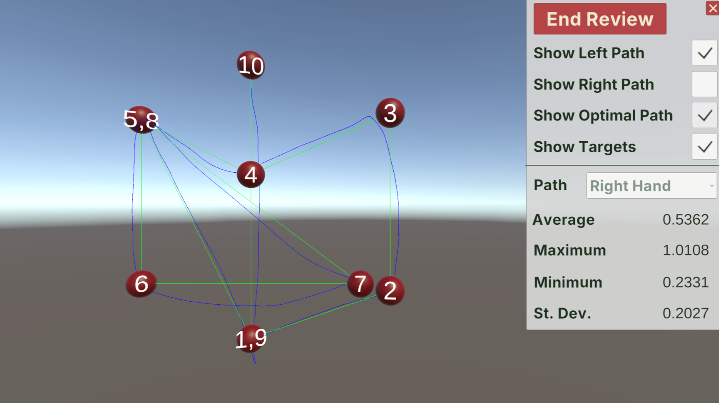

Statistical View
The Statistical View page computes a top-level statistical analysis of the raw data, using Unity’s XCharts library to visualize the deviations. The Deviation panel displays information about the distance between the participant’s motions and the optimal ones in centimeters, separated by hand (left or right), reaching phase (Seek, Approach, or Search), and three-dimensional plane (X, Y, Z, or overall). The Target-to-Target time displays information about the number of milliseconds from the beginning of the Approach phase and the end of the Seek phase for each target. Finally, the four charts are visual representations of each hand’s deviations across the time of the trial, each phase shown in a different color according to the legend panel. This analysis can be exported by pressing the Export Data button if desired.
